# Module 1

## Advanced Keras Functionalities

## Custom Layers

## 📌 Creating Custom Layers in Keras­

Custom layers provide a mechanism to define operations and behaviors in a neural network that go beyond what is offered by Keras’s built-in layers.

They enable the implementation of **task-specific logic**, **novel research ideas**, and **optimized computational flows**, making them indispensable for both experimentation and production-grade modeling.

### 🔹 Why Use Custom Layers?

Although standard layers such as Dense, Conv2D, or LSTM serve a wide range of applications, there are situations where default implementations are not enough.

Custom layers are essential in the following scenarios:

* **Implementing novel research**: When designing new algorithms or techniques that are not yet part of the Keras API.
* **Task-specific behavior**: When an application requires a specific mathematical operation or architectural element that isn’t supported natively.
* **Optimizing for data or constraints**: Tailoring layers to better handle specific types of data distributions, memory constraints, or latency-sensitive applications.
* **Encapsulation of logic**: Wrapping complex or repeated logic into a layer promotes code readability, modularity, and reuse across different models.

By creating custom layers, it becomes possible to extend Keras and build models that are **more fine-tuned**, **highly adaptable**, and **research-ready**.

### 🔹 How to Create a Custom Layer in Keras

A custom layer in Keras is implemented by subclassing *tensorflow.keras.layers.Layer* and overriding three main methods:

***1. __init__(self, ...)***

* Initializes the layer’s attributes and configuration.
* Typically used to define constants or input parameters (e.g., number of units, activation function type).

***2.* build(self, input_shape)**

* Creates and initializes the layer’s trainable weights.
* Called automatically the first time the layer is used (during the first forward pass).
* Should define self.add_weight(...) for custom weight variables.

***3.* call(self, inputs)**

* Defines the forward computation logic.
* Implements the actual transformation applied to the inputs using TensorFlow operations.
* Can include activation functions, mathematical operations, or sub-layer calls.

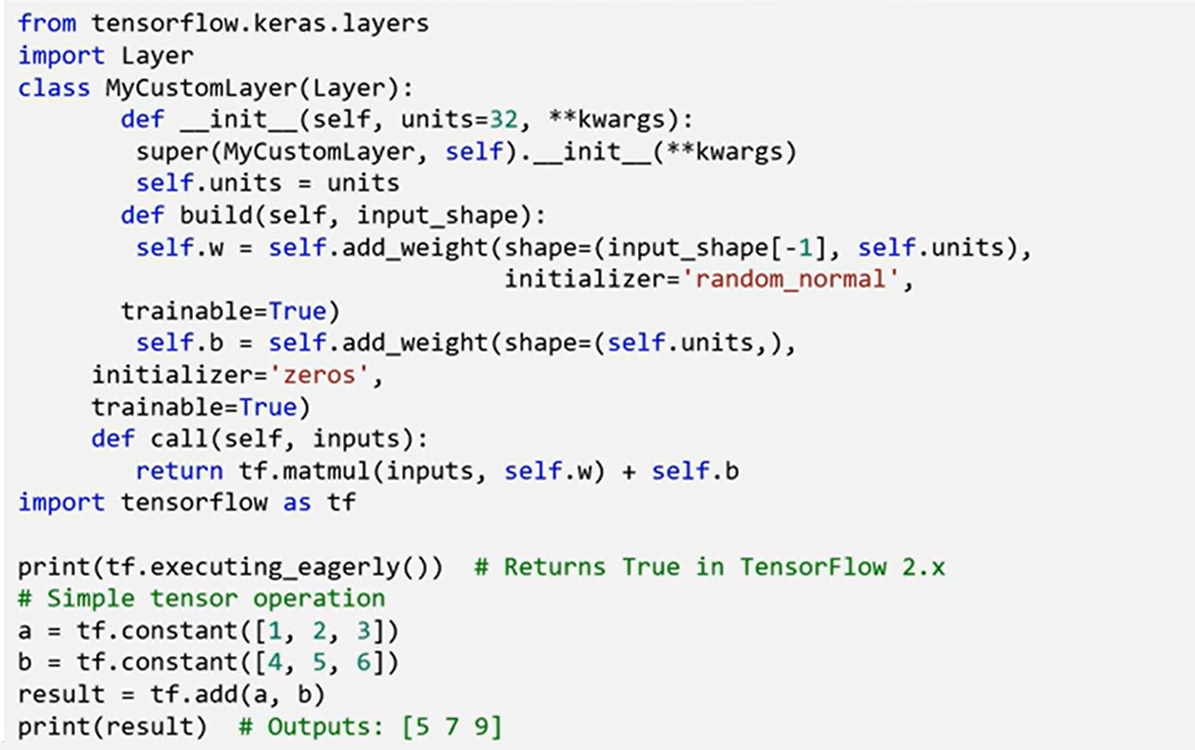

**🔗 Using a Custom Layer in a Model**

Once defined, a custom layer integrates seamlessly into a Keras model. For example, in a simple *Sequential* model, the custom dense layer can be used like any standard layer:

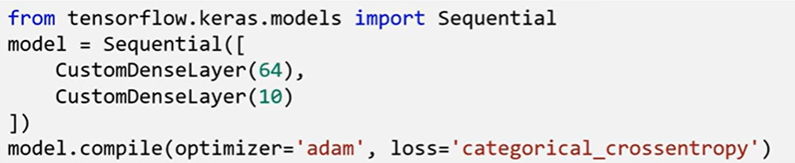

This ease of integration makes it practical to test and prototype novel components without modifying the broader model logic.

### ✅ Takeaways

✅ Custom layers expand the expressive power of Keras beyond built-in layers.

✅ Useful for tailoring models to domain-specific needs or implementing operations based on new research.

✅ The three essential methods to override *are* ***__init__***, ***build***, and ***call***, which control initialization, weight setup, and forward logic respectively.

✅ Once implemented, a custom layer behaves like any other layer in the Keras ecosystem and can be added to both Sequential and Functional models.

✅ Experimenting with custom layers deepens understanding of neural network internals and supports innovation in model design.

📌 💡 ✅ ❌ 🚫 ⚠️ 🔍 ℹ️ 🧠 ⚙️ 🔧 🧰 🛠 🧩⚡ 🔗

## 📌 Advanced Keras Functional API

The Functional API in Keras provides the architectural flexibility required for building complex deep learning models that go beyond the linear constraints of the Sequential API. While **Sequential API** is ideal for simple, linear layer stacks, the **Functional API** allows for **non-linear, multi-branch, and multi-input/output architectures.**

### 🔹 Functional API Capabilities

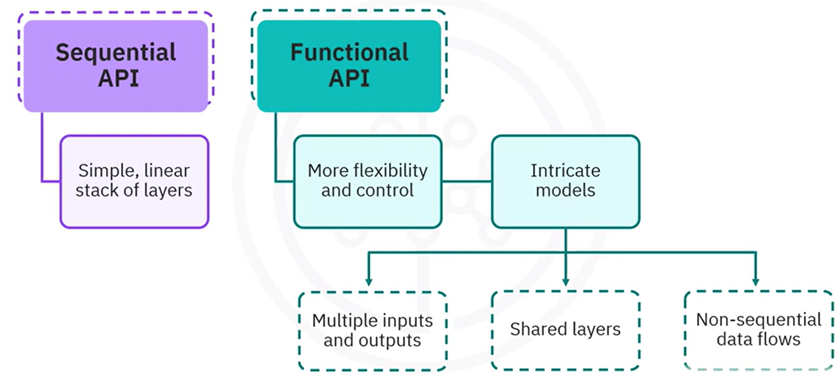

* **Multi-Input & Multi-Output Architectures**: Supports models that can simultaneously process multiple inputs (e.g., different sensor data or feature types) and generate multiple outputs (e.g., multi-task learning or multi-label classification).
* **Shared Layers**: Enables reusing the same layer instance multiple times across a model, which is especially useful in architectures where certain layers share parameters.
* **Non-Sequential Graph Structures**: Permits creation of models with non-linear flows, skip connections, residual links, and parallel branches.
* **Explicit Model Definition**: Inputs, transformations, and outputs are defined as explicit, connectable nodes (tensors), making the model structure transparent and easy to debug.

### 🔹 Sequential API vs Functional API

🔧 **Sequential API example**:

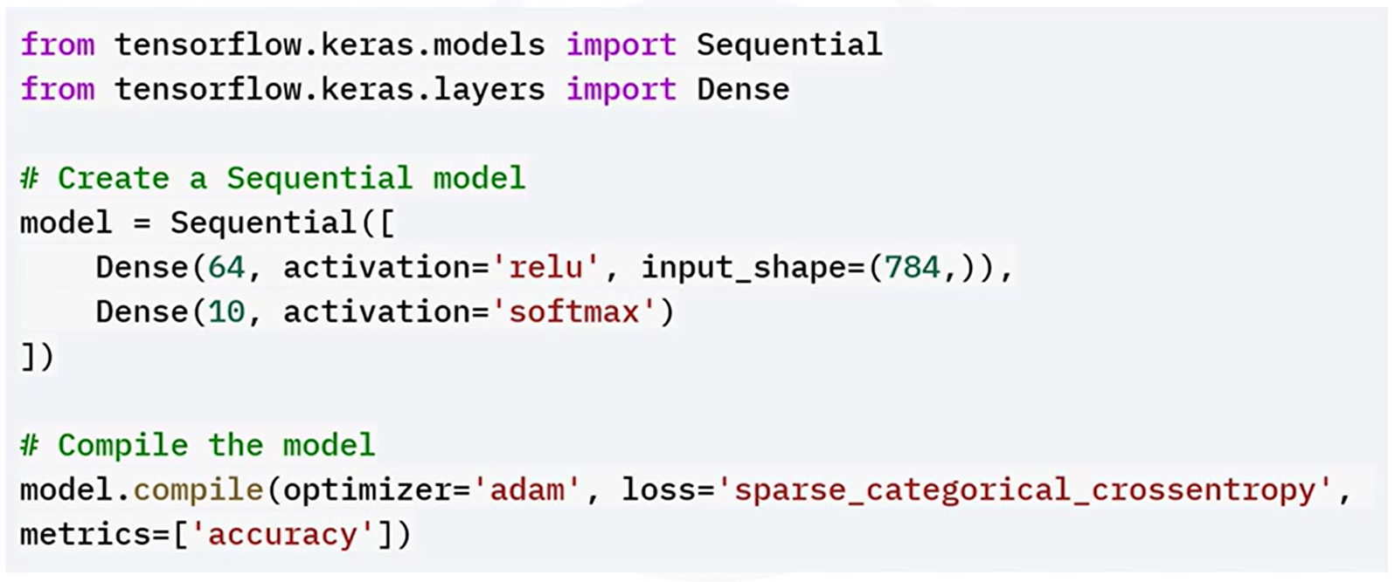

Layers are added in a linear stack. The first dense layer is added with relu activation, and the output layer is added with softmax activation for classification.

This approach is suitable for straightforward tasks like single-input feedforward classification. Layers are stacked in order, with no flexibility for branching or multiple outputs.

🔧 **Functional API example**:

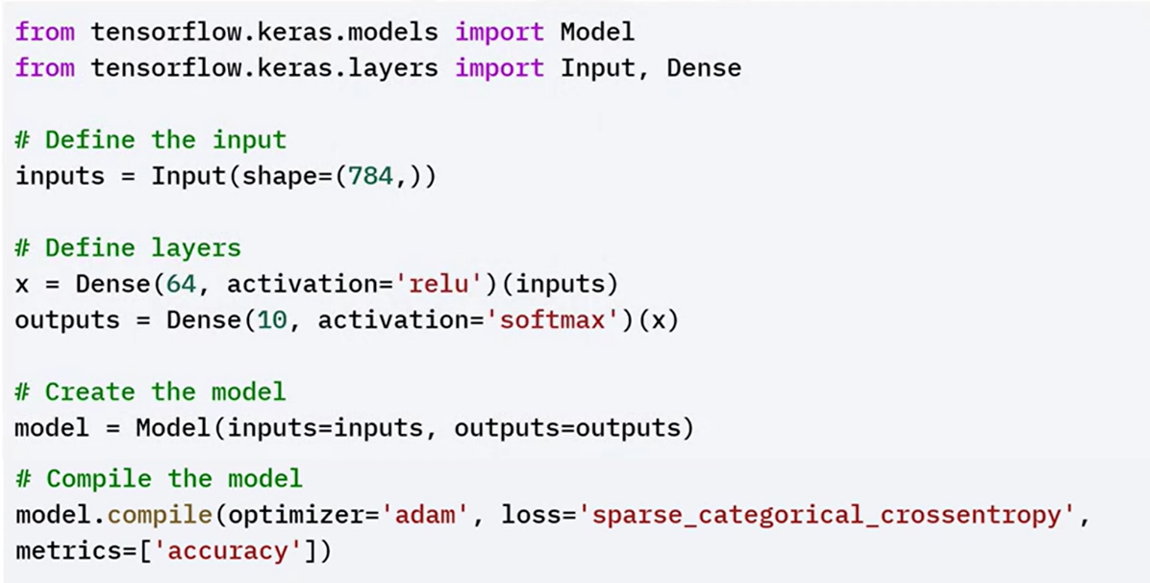

In the functional API example, you first define an input layer. Connect the first dense layer with relu activation to the input layer. The output layer has the softmax activation. Then combine the input and output layers into a model.

This definition allows for inspecting and manipulating each step explicitly, enabling the extension to more sophisticated configurations (e.g., dual-branch inputs or skip connections).

🔧 **Functional API Example: Multi-Input Model**:

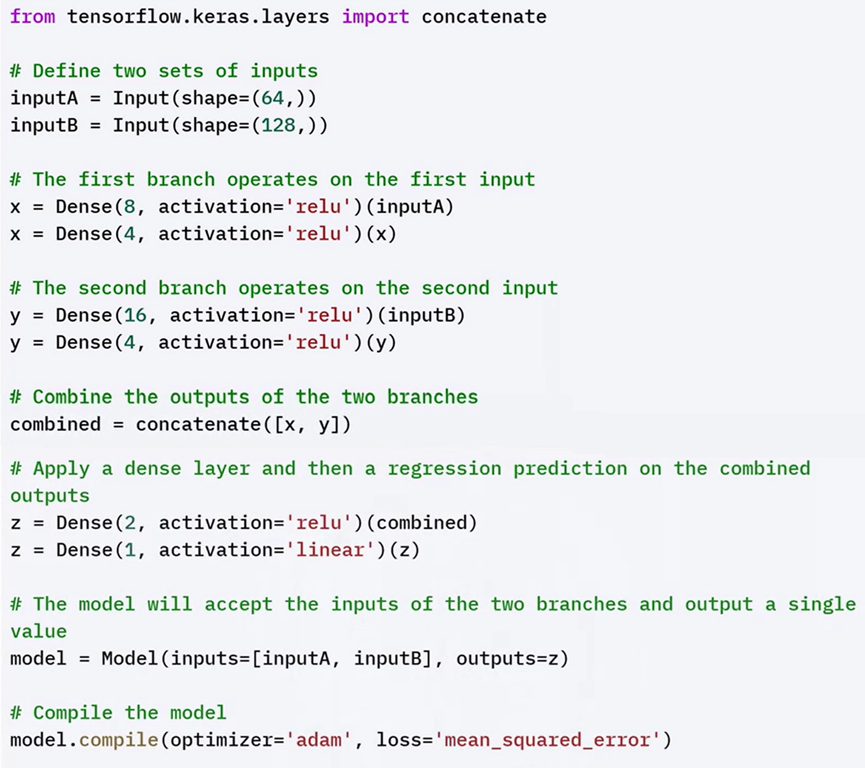

### 🔹 Functional API Advantages

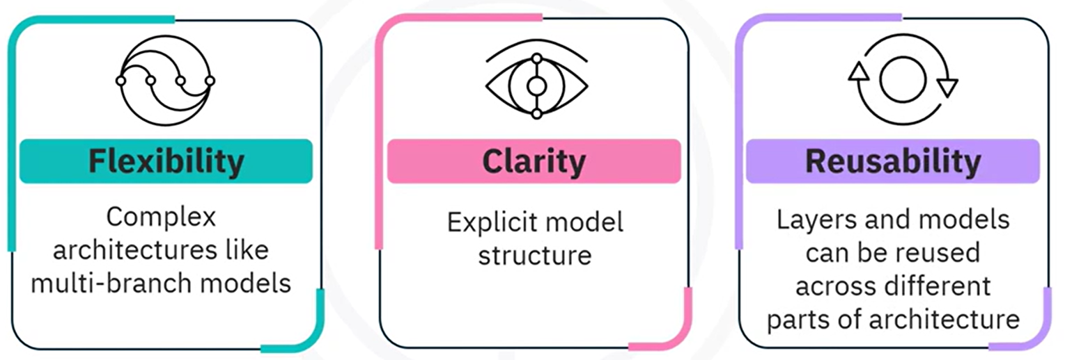

✅ **Flexibility:**

Supports **arbitrary model topologies.** What enables creation of **multi-input/multi-output** models, **skip connections**, **branched logic**, and **shared layers**.

✅ **Clarity:**

Each model component — inputs, intermediate layers, and outputs — is **explicitly defined and connected**, making the architecture more transparent.

Easier to **visualize**, **understand**, and **debug** than the Sequential API.

✅ **Reusability:**

Layers can be **reused** across different parts of a model without redefining them.

Shared layer instances retain their learned weights across the reused paths.

### ✅ Takeaways

✅ The Functional API is indispensable when building deep learning models that require structural flexibility and fine-grained architectural control.

✅ It allows creation of **multi-input/output**, **layer-sharing**, and **non-linear** models, which are otherwise impossible with Sequential.

✅ Its transparency makes it easier to **debug**, **visualize**, and **adapt** models in research and industrial workflows.

✅ For modern applications involving hybrid data sources or multiple prediction targets, the Functional API is the standard approach.

## 📌 Keras Functional API and Subclassing API

The **Functional API** in Keras allows the creation of flexible and complex neural network architectures beyond the limitations of the Sequential API. It supports non-linear topologies, multiple inputs and outputs, and shared layers.

In parallel, the **Model Subclassing API** provides the highest level of flexibility by allowing users to define custom models by extending the base Keras Model class.

These two approaches are foundational for solving advanced problems in research and development.

### 🔹 Functional API: Capabilities and Architecture

While Sequential is limited to stacking layers linearly, the Functional API allows defining models as **graphs of layers**, where the **connections** between layers are explicitly constructed. This is especially beneficial for building models that:

* Require **multiple inputs** and/or **multiple outputs**
* Use **shared layers** (e.g., identical weight layers applied to different inputs)
* Involve **non-linear data flows** (e.g., branching, merging, or skip connections)

This flexibility is crucial in **research** and in solving **complex problems** that require customized model behavior

#### ⚙️ Syntax and Basic Workflow

In the Functional API:

* 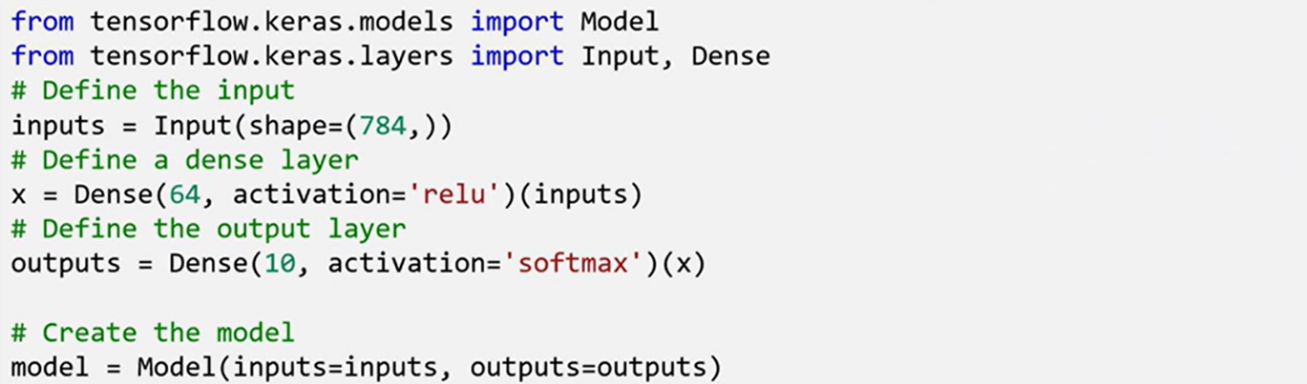You begin by defining one or more **Input layers**, specifying the shape of the input data.
* Each **Dense layer** or transformation is then defined and explicitly connected to the previous layer’s output.
* The model is completed by combining the input(s) and output(s) into a Model.

Each **Dense layer** has a parameter unit, which refers to the **dimensionality of the output space**. Activation functions such as relu (for hidden layers) and softmax (for multiclass classification outputs) are used to introduce non-linearities and enable learning complex mappings.

#### ⚙️ Advanced Use Cases of Functional API

##### **🔗 1. Multiple Inputs and Outputs**

One of the key advantages of the Functional API is the ability to define models with **multiple input layers and multiple output layers**. This is particularly valuable in scenarios like **multitask learning**, where different outputs need to be predicted from shared and specialized parts of the network.

* Two separate input layers are defined, each with its own shape.
* Each input is processed through its own set of layers (independent branches).
* The outputs of these branches can be **merged** (e.g., concatenated), and additional layers can be applied.
* Finally, the network splits again to generate **multiple outputs**, each possibly corresponding to a different task.

This architecture supports learning **shared representations** while still making distinct predictions per task

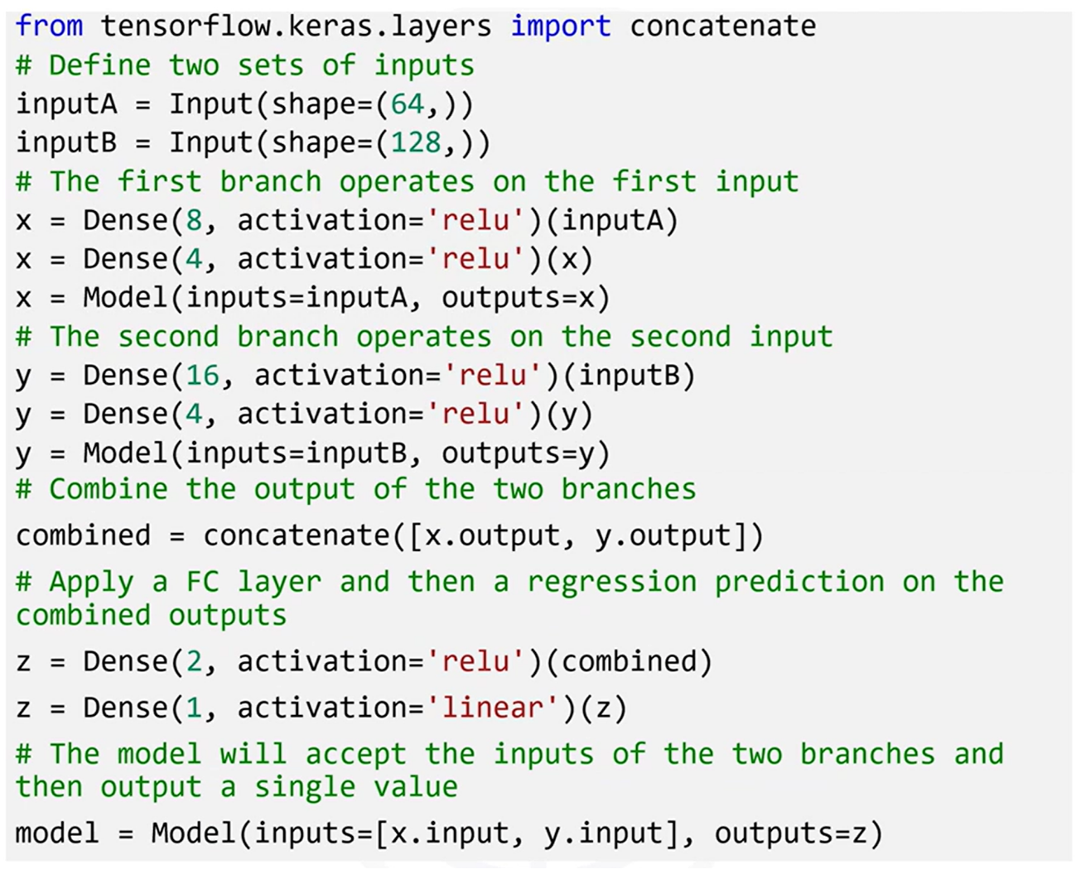



##### **🔗 2. Shared Layers**

Another powerful feature of the Functional API is the ability to **share layers across inputs**. This means a single layer (and its weights) can be applied to different inputs, which is essential in applications like **Siamese networks**.

In a Siamese network:

* A **shared Dense layer** is defined once.
* Two different input layers are processed using this shared layer (i.e., the same layer instance is applied to both).
* The outputs from these shared transformations are then compared or further processed.

This approach is used when two different inputs need to be processed **identically** to compare their embeddings or extract similarities.

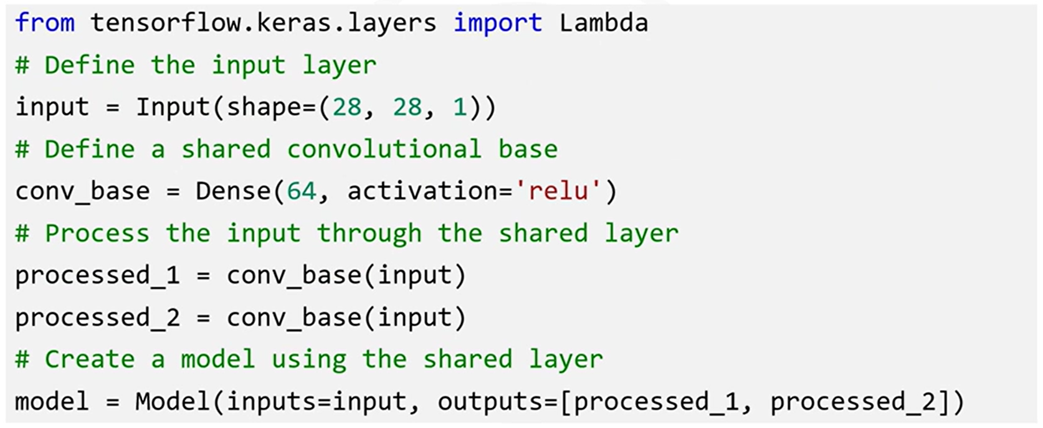

#### ⚙️ Full Example: Combining All Features

In a more complex setup:

* The model has **two branches**, each starting from a different input.
* Each branch passes through **convolutional layers**, followed by **pooling** and **flattening** layers.
* The resulting outputs are **concatenated** into a merged representation.
* This merged vector is then passed through additional Dense layers.
* A final **single output** is produced (e.g., binary or multiclass classification).

This architecture demonstrates how multiple inputs, branching paths, and merging layers can all be implemented seamlessly using the Functional API.

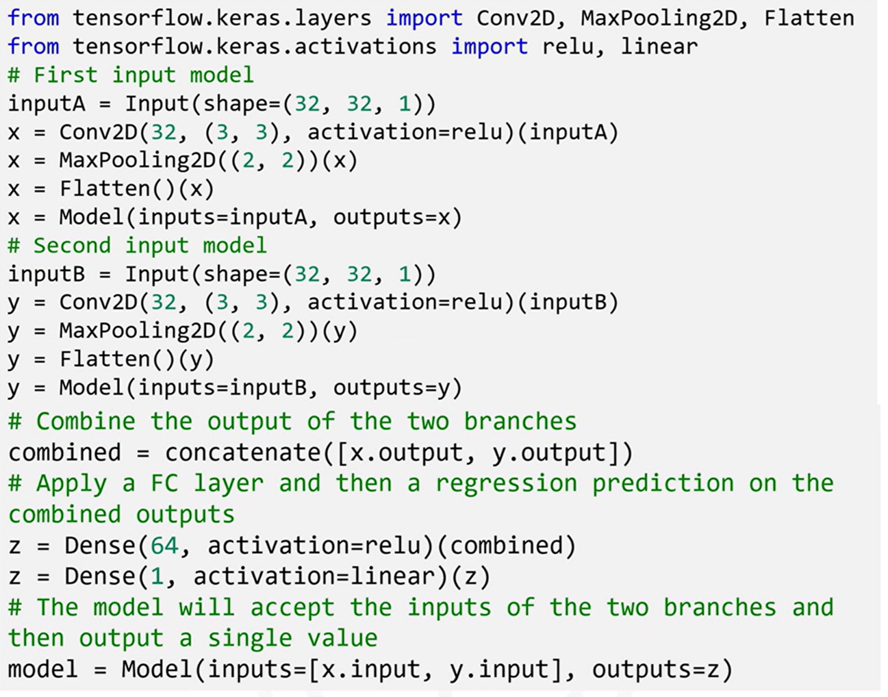

### 🔹 Model Subclassing API: Custom and Dynamic Models

Beyond the Functional API, Keras also supports a **Model Subclassing API**, which offers the **most control and flexibility**.

Instead of defining a model by stacking or connecting layers declaratively, a model is defined by **subclassing tf.keras.Model** and **manually implementing the architecture** in code.

**🧱 Structure of Subclassed Models**

* Layers are **defined in the __init__() method**, like attributes of a class.
* The forward pass is written explicitly in the **call() method**, where the order and logic of applying each layer is controlled programmatically.

This model definition style is **imperative**, allowing the forward pass to contain conditional logic, loops, or dynamic behaviors — which is not possible in static graph models like Sequential or Functional API.

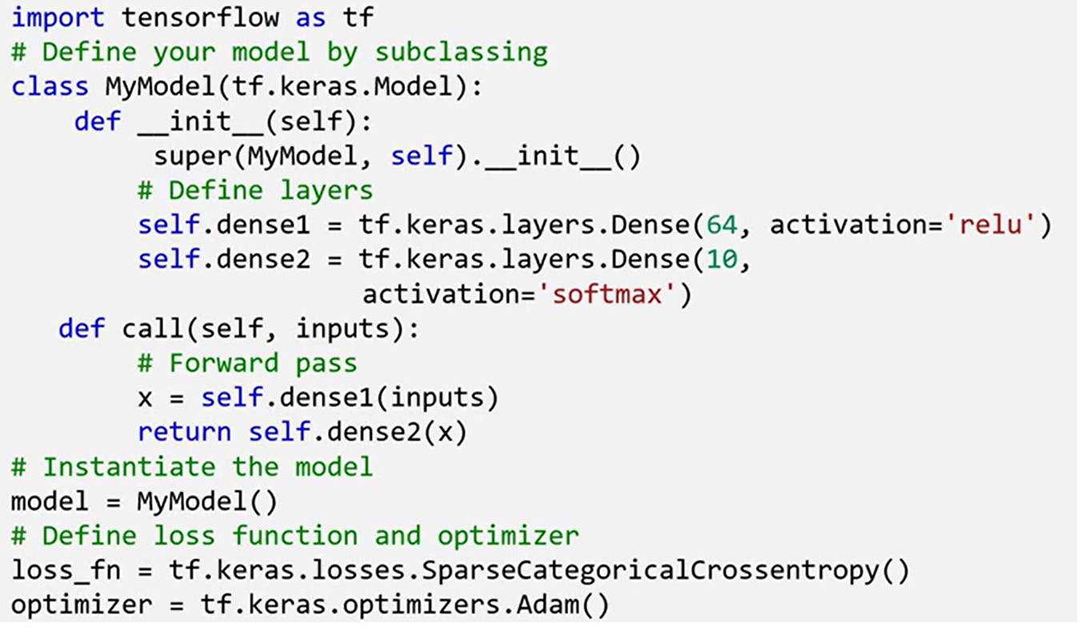

#### When to Use Subclassing API

Subclassing is particularly useful in advanced or unconventional scenarios:

* **Dynamic Architectures**: When the model’s structure must change during runtime, based on input data or conditional flows. This is common in **reinforcement learning** or **adaptive models**.
* **Custom Training Loops**: When full control over training behavior is needed — such as tracking custom metrics, defining loss manually, or implementing specific update steps.
* **Research and Prototyping**: Useful when designing **novel layer types** or **experimental architectures** that don’t fit neatly into Keras's standard layer types.

#### ⚙️ Training with *tf.GradientTape*

Models built via subclassing are often trained using **custom training loops** with tf.GradientTape instead of the standard .fit() method.

The training loop involves:

* Running the forward pass manually
* Calculating loss
* Tracking gradients with tf.GradientTape
* Applying gradients using an optimizer

This method provides **finer control** over every training step.

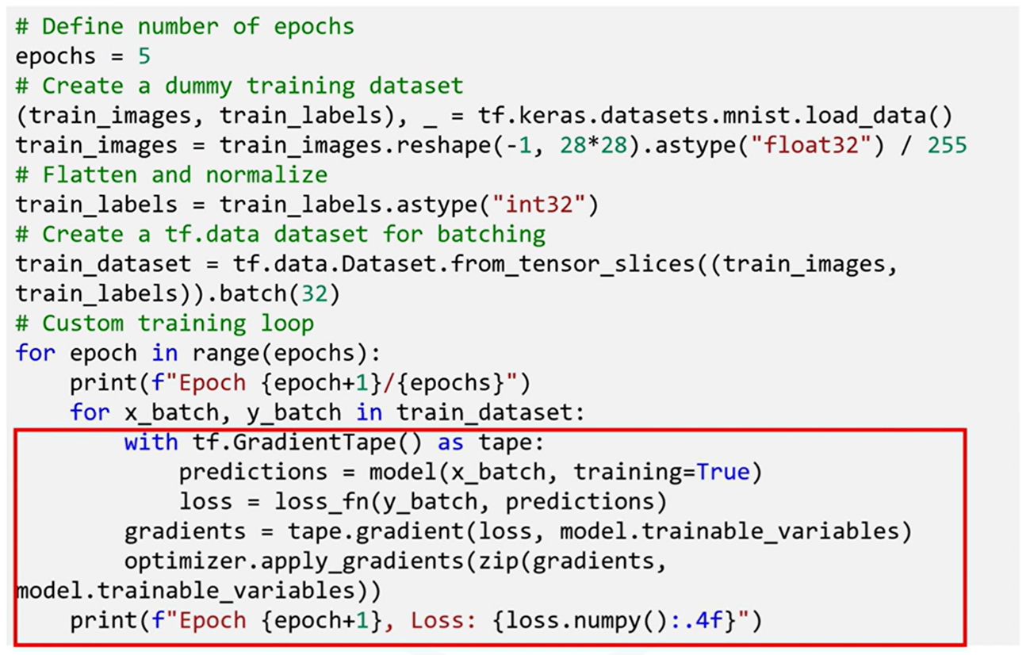

#### Benefits of Subclassing API

Enables building models with **dynamic graphs**, where the structure can change on-the-fly during training.

Unlike the Functional and Sequential APIs (which define **static graphs**), subclassed models can adapt their architecture conditionally.

Useful for advanced domains such as:

* Reinforcement learning agents
* Attention-based models with adaptive masking
* Research models with evolving internal states or dynamic flow logic

### ✅ Takeaways

✅ The **Functional API** allows building flexible, reusable, and modular networks with complex topologies, including multi-input/output models and shared-layer architectures.

✅ **Shared layers** and **non-linear data flows** enable design patterns like Siamese networks, multitask models, and hierarchical pipelines.

✅ The **Subclassing API** offers the ultimate freedom, enabling dynamic computation graphs, arbitrary control flows, and custom training logic.

✅ **Custom training loops** via tf.GradientTape allow training models in ways that are not supported by .fit(), giving total control over loss computation, updates, and behavior.